Topic 2 / Chapter 4

Database Management & CIS 1246

Author: | Christopher Sigouin
Date: | February 2
Date Due: | February 2 (10pm)
Assignment: | Topic 2
 | Task: 1
Mark: ____________
Chapter 4 / Case Problem #10

During peak periods, Temporary Employment Corporation (TEC) places temporary workers in companies. TEC’s manager gives you the following description of the business:

• TEC has a file of candidates who are willing to work.

• Any candidate who has worked before has a specific job history. (Naturally, no job history exists if the candidate has never worked. () Each time the candidate works, one additional job history record is created.

• Each candidate has earned several qualifications. Each qualification may be earned by more than one candidate. (For example, more than one candidate may have earned a Bachelor of Business Administration degree or a Microsoft Network Certification, and clearly a candidate may have earned both a BBA and a Microsoft Network Certification.)

• TEC offers courses to help candidates improve their qualifications.

• Every course develops one specific qualification; however, TEC does not offer a course for every qualification. Some qualifications are developed through multiple courses.

• Some courses cover advanced topics that require specific qualifications as prerequisites. Some courses cover basic topics that do not require any prerequisite qualifications. A course can have several prerequisites. A qualification can be a prerequisite for more than one course.

• Courses are taught during training sessions. A training session is the presentation of a single course. Over time, TEC will offer many training sessions for each course; however, new courses may not have any training sessions scheduled right away.

• Candidates can pay a fee to attend a training session. A training session can accommodate several candidates, although new training sessions will not have any candidates registered at first.

• TEC also has a list of companies that request temporaries.

• Each time a company requests a temporary employee, TEC makes an entry in the Openings folder. That folder contains an opening number, a company name, required qualifications, a starting date, an anticipated ending date, and hourly pay.

• Each opening requires only one specific or main qualification.

• When a candidate matches the qualification, the job is assigned, and an entry is made in the Placement Record folder. The folder contains such information as an opening number, a candidate number, and the total hours worked. In addition, an entry is made in the job history for the candidate.

• An opening can be filled by many candidates, and a candidate can fill many openings.

• TEC uses special codes to describe a candidate’s qualifications for an opening. The list of codes is shown in Table P4.10.

CODE DESCRIPTION
SEC-45 Secretarial work; candidate must type at least 45 words per minute
SEC-60 Secretarial work; candidate must type at least 60 words per minute
CLERK General clerking work
PRG-VB Programmer, Visual Basic
PRG-C++ Programmer, C++
DBA-ORA Database Administrator, Oracle
DBA-DB2 Database Administrator, IBM DB2
DBA-SQLSERV Database Administrator, MS SQL Server
SYS-1 Systems Analyst, level 1
SYS-2 Systems Analyst, level 2
NW-NOV Network Administrator, Novell experience
WD-CF Web Developer, ColdFusion

TEC’s management wants to keep track of the following entities:
COMPANY, OPENING, QUALIFICATION, CANDIDATE, JOB_HISTORY, PLACEMENT, COURSE, and SESSION. Given that information, do the following:

a. Draw the Crow’s Foot ERDs for this enterprise.
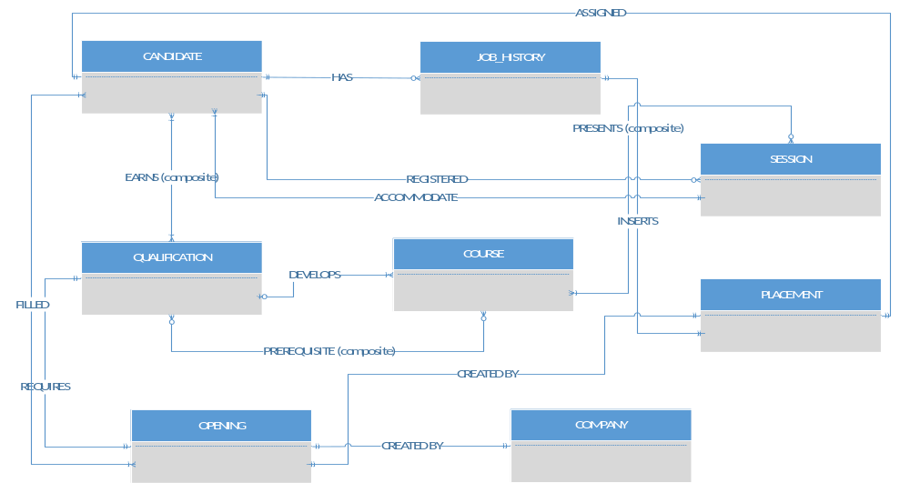

b. Identify all necessary relationships. ( SEE CHART UNDER SECTION C )

c. Identify the connectivity for each relationship.

ENTITY | RELATIONSHIP | CONNECTIVITY | ENTITY
CANDIDATE | has | 0:M | JOB_HISTORY
CANDIDATE | earns / earned by | M:N | QUALIFICATION
COURSE | develops | 0:1 | QUALIFICATION
QUALIFICATION | developed by | 1:M | COURSE
COURSE | has a prerequisite / has a prerequisite | M:N | QUALIFICATION
SESSION | presents / presented by | M:N | COURSE
SESSION | accommodate | 1:M | CANDIDATE
CANDIDATE | be registered for | 0:M | SESSION
OPENING | created by | 1:1 | COMPANY
OPENING | require | 1:1 | QUALIFICATIONS
PLACEMENT | created by | 1:1 | OPENING
PLACEMENT | assigned to | 1:1 | CANDIDATE
PLACEMENT | inserts an entry | 1:1 | JOB_HISTORY
OPENING | filled by / can fill | M:N | CANDIDATE

d. Identify the mandatory and optional dependencies for the relationships.

ENTITY | MANDATORY / OPTIONAL DEPENDENCY | ENTITY
CANDIDATE | CANDIDATE has JOB_HISTORY: Optional  JOB_HISTORY has CANDIDATE: Mandatory | JOB_HISTORY
CANDIDATE | CANDIDATE earns QUALIFICATION: Mandatory  QUALIFICATION earned by CANDIDATE: Mandatory | QUALIFICATION
COURSE | COURSE develops QUALIFICATION: Optional  QUALIFICATION developed by COURSE: Mandatory | QUALIFICATION
COURSE | COURSE is prerequisite QUALIFICATION: Optional  QUALIFICATION is prerequisite COURSE: Optional | QUALIFICATION
SESSION | SESSION presents COURSE: Mandatory  COURSE presented by SESSION: Optional | COURSE
SESSION | SESSION accommodates CANDIDATE: Mandatory  CANDIDATE registers for SESSION: Optional | CANDIDATE
OPENING | OPENING created by COMPANY: Mandatory  COMPANY creates OPENING: Mandatory | COMPANY
OPENING | OPENING has a required QUALIFICATION: Mandatory  QUALIFICATION requirement OPENING: Mandatory | QUALIFICATION
PLACEMENT | OPENING creates PLACEMENT: Mandatory  PLACEMENT created by OPENING: Mandatory | OPENING
PLACEMENT | PLACEMENT assigned to CANDIDATE: Mandatory  CANDIDATE is assigned PLACEMENT: Mandatory | CANDIDATE
PLACEMENT | PLACEMENT inserts entry JOB_HISTORY: Mandatory  JOB_HISTORY inserted by PLACEMENT: Mandatory | JOB_HISTORY
OPENING | OPENING filled by CANDIDATE: Mandatory  CANDIDATE can fill OPENING: Mandatory | CANDIDATE

e. Resolve all M:N relationships.

There are four M:N relationships I identified.

CANDIDATE – QUALIFICATION
(CREATE ENTITY: WORKER)
COURSE – QUALIFICATION
(CREATE ENTITY: PREREQUISITES)
SESSION – COURSE
(CREATE ENTITY: PRESENTATOR)
OPENING – CANDIDATE
(USE ENTITY: PLACEMENT)
The relationship between opening and candidate dictates that a placement
can be established or “ filled by “. Connectivity’s for the entities
would change accordingly for OPENING and CANDIDATE. JOB_HISTORY
will remain the same.

